JnJ RDC KPI

- Dock to Stock

- Measure time taken for physical goods reach warehouse till in the location (by putaway).
- Dock to Stock (Hrs) – TAT hr = 24 hrs, if the duration from Dock to Stock is within 24 hrs, it considered meet TAT/SLA.
- Currently, Muthu is manually record the physical goods arrived into warehouse as “Received Date & Time”.
- Proposed to use first LP scan date/time as start date/time
- Used putaway date/time in the report in Rabbit “Inbound TAT ASN to Putaway” as putaway date/time.

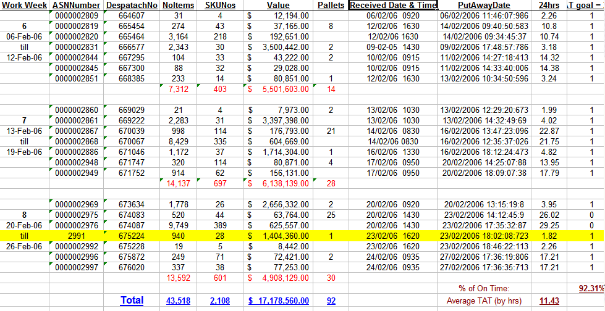

- Cargo Readiness

- Measure time taken for order created in WMS to shipment completed packing and in staging area.
- Start time will be taken from WMS when the date/time that order created in WMS. End time will be after ops complete Dim/Wgt enter in the Rabbit (New Outgoing Shipment Entry screen).
- Selection for the report to be generated : Date from and Date to.
- Fields in the report : Orderkey, weborderkey, customer PO#, Shipto Party, Shipto Country, Order creation Date/Time, Dim/Wgt date/time stamp, duration.

- Cargo Ready to shipment

- Measure time taken for order packing and ready at Staging area to Forwarder pickup.
- Start time will be taken from WMS when the date/time that Dim and Wgt had entered into WMS.
- End time will be after Forwarder had collected the cargo - ops complete ship wave time stamp.
- Fields in the report : Orderkey, weborderkey, customer PO#, Shipto Party, Shipto Country, Dim/Wgt date/time stamp, Ship Wave Date/time, duration.

- Cycle count Or Inventory

- Need to know how JnJ classify the SKU in class A-E.
- Monthly report “Monthly ABC Report” send to JnJ (Veron) at every 1st day of month.
- This report will classify the SKU into A to Z as follow logic;

1. 12 months of past data from the day the report is generated.
2. Sales qty is the quantity shipped during the period
3. Sku's which forms the 70% of the total sales will be classified 'A'
4. Sku's which forms the 20% of the total sales will be classified 'B'
5. Sku's which forms the 10% of the total sales will be classified 'C'
6. Rest of the Sku's with sales qty <=52 will be classified 'E'

- Next step??

